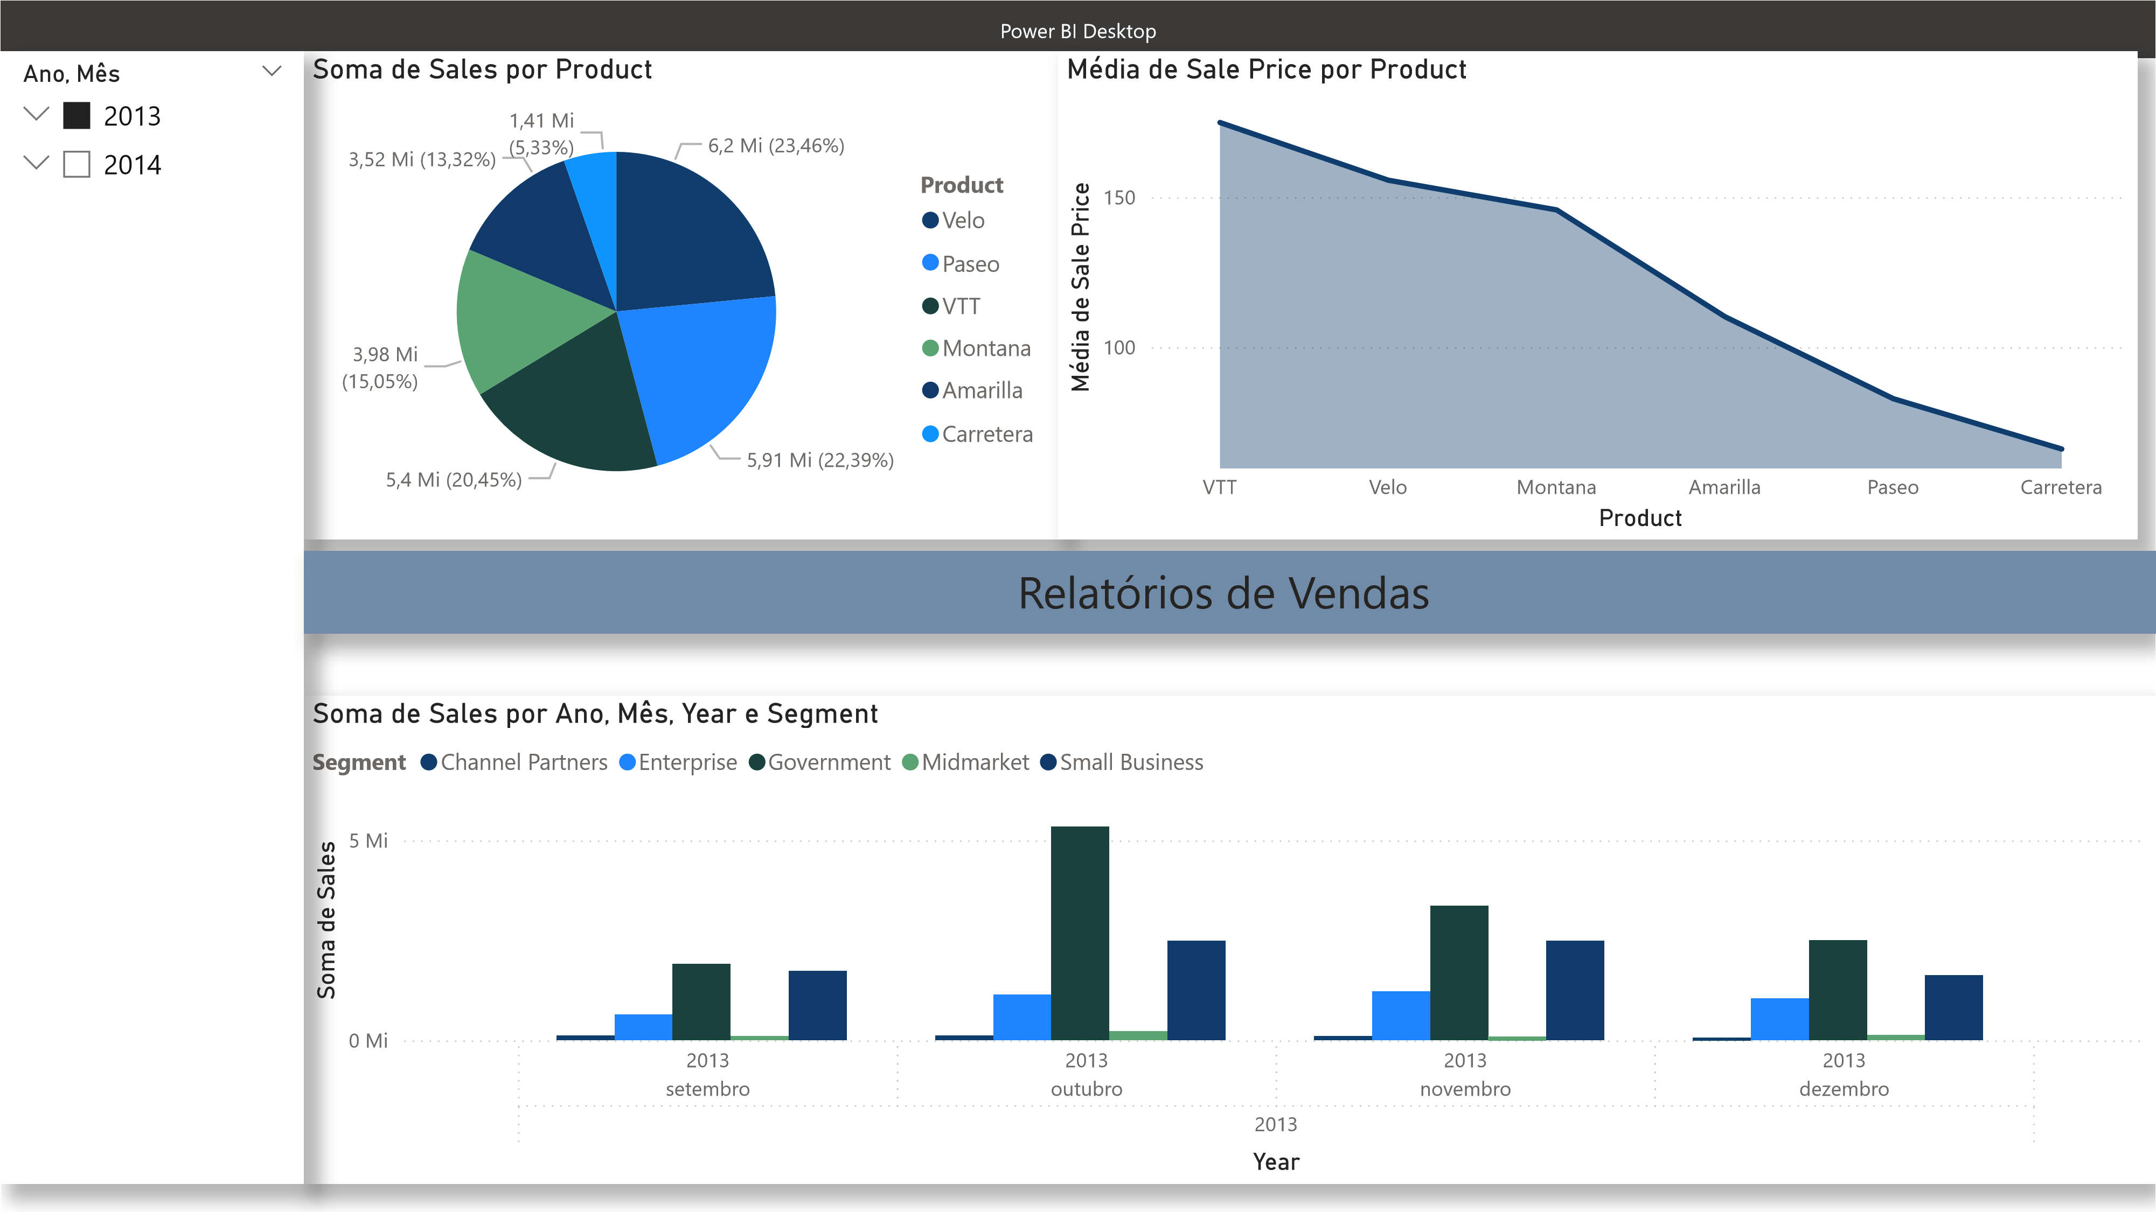
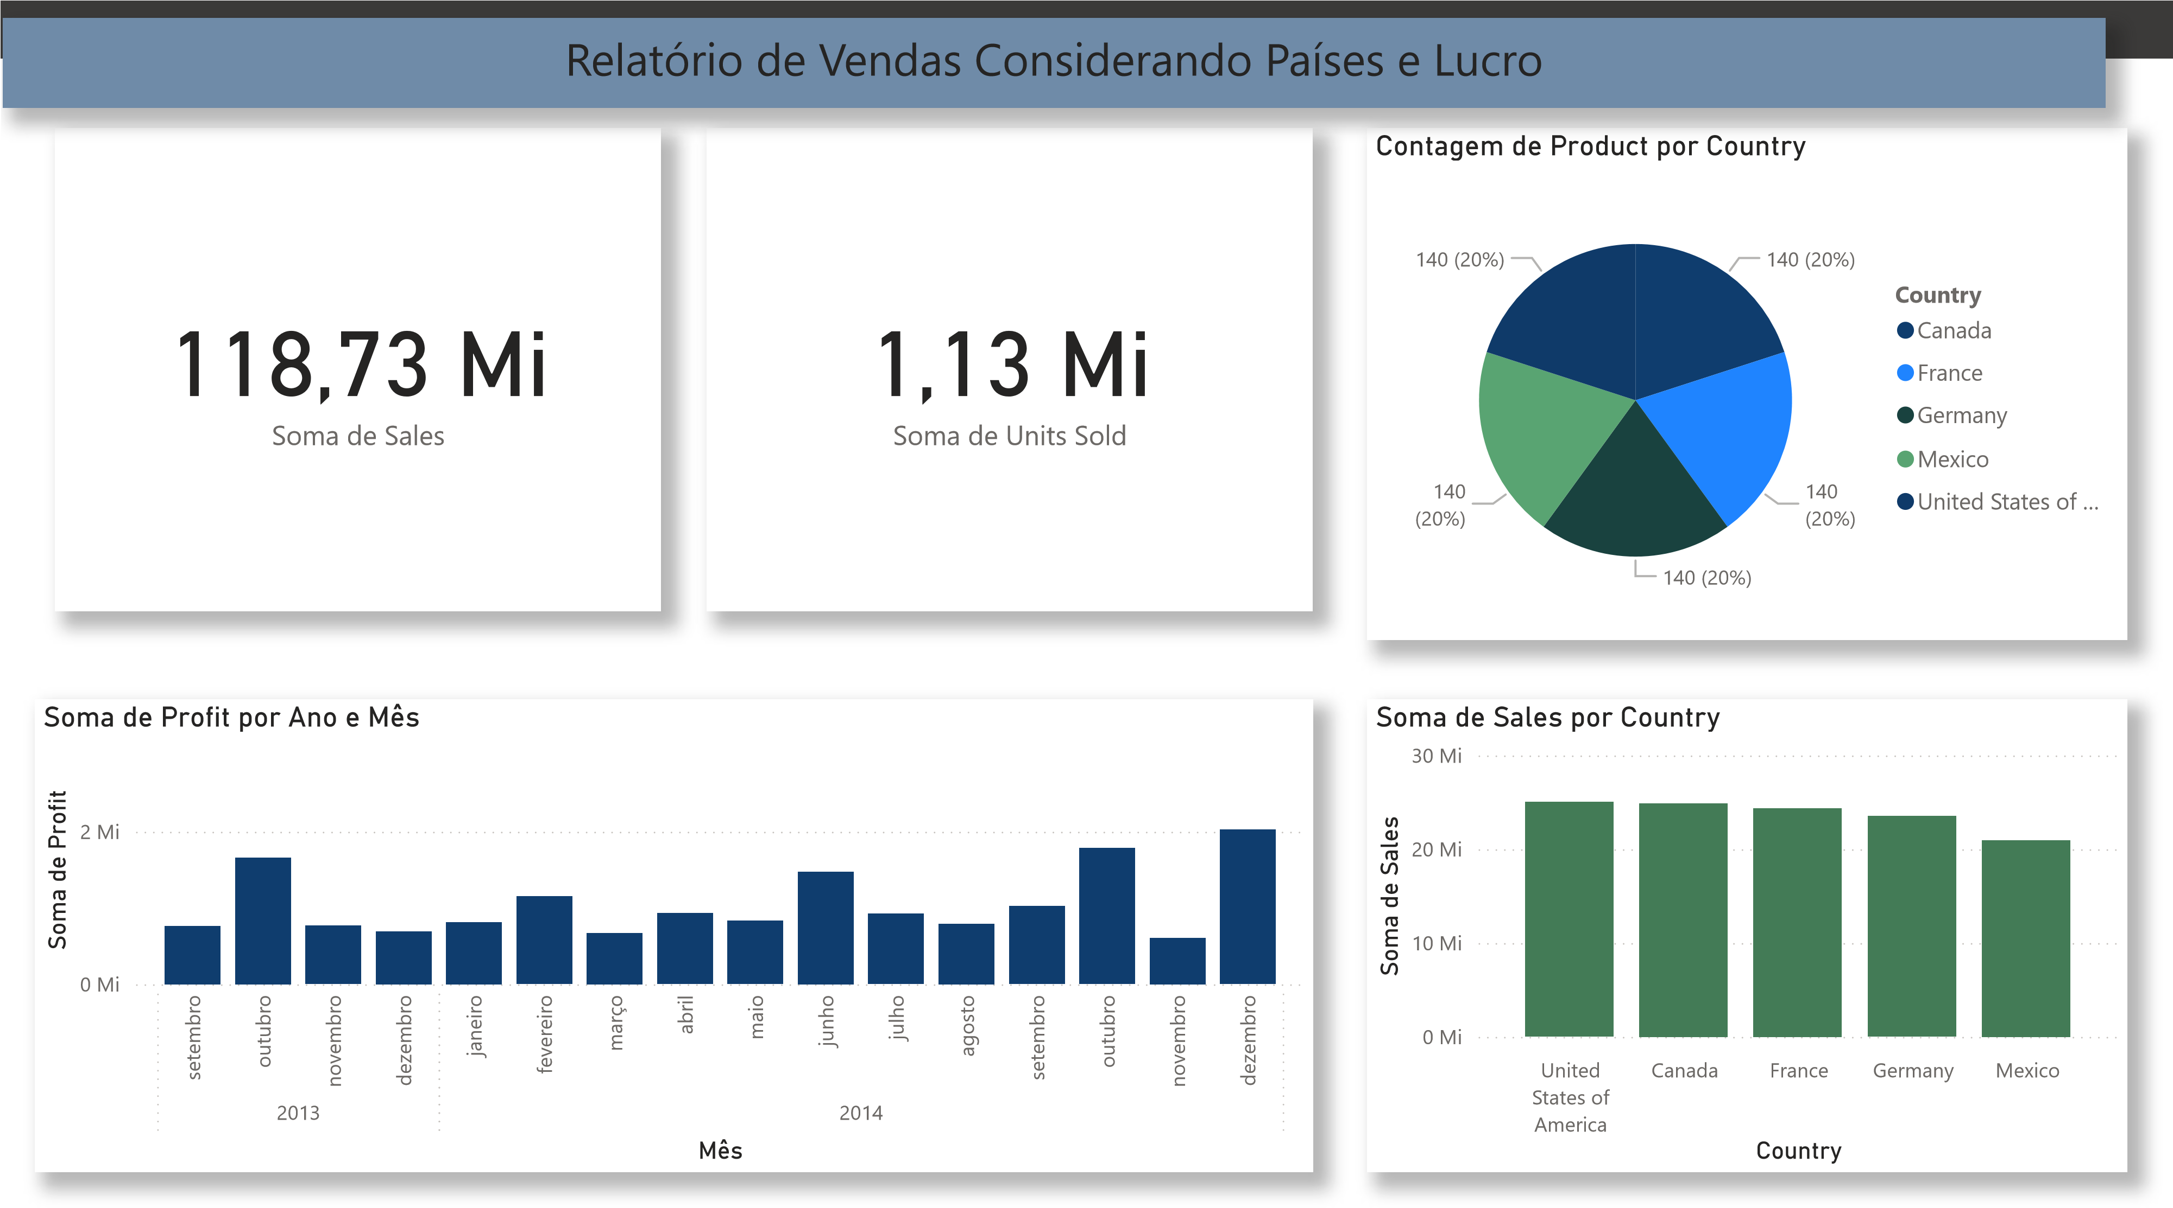

 | Análise de Vendas por País (Receita e Quantidade)^{Power BI Desktop}
Soma de Profit por Segment  (23,66  %  )  1  ,32 Mi (7,52%  )  0  ,66 Mi (3,77%  )  4  ,14 Mi | 11,39 Mi (65,04%) | Segment  Government  Small Business  Channel Partners  Midmarket  Enterprise | Soma de Sales e Soma de Units Sold por Country  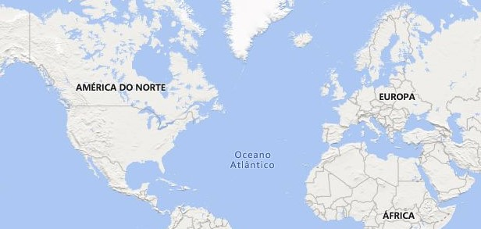  © 2025 TomTom, © 2025 Microsoft Corporation,  © 2025 TomTom, © 2025 Microsoft Corporation,  p  © O  penStreetMa  penStreetMa  p  © O
 | 11,39 Mi (65,04%) |  | Contagem de Segment por Country  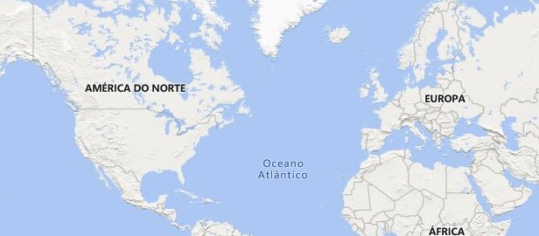  © 2025 TomTom, © 2025 Microsoft Corporation,  © 2025 TomTom, © 2025 Microsoft Corporation,  p  © O  penStreetMa  penStreetMa  p  © O

